LAL 7/ 2018/ Humboldt School

Language/ Vocabulary:

1. Your teacher will present ten new words to you. Memorize them in the next five minutes Then write them down.

[Ten adjectives ... As sly as a fox, as brave as a , as tiny as a ... as fast as a hare, as strong as an ox, as stealth as a tiger , .---

2. You have three minutes. Write down ...

- Adjectives which describe people: tall, ______________________________________

_____________________________________________________________________

- Things you find in school: classrooms, ______________________________________

_____________________________________________________________________

- Activities/ hobbies which teenagers find interesting: __________________________

_____________________________________________________________________

3. Match the opposites below: 4. Match the synonyms below:

tall boring nice awesome

nice small amazing beautiful

exciting mean awful kind

usual fast slim terrible

slow unusual pretty thin

Language/ Grammar:

Questions: Ask the correct questions.

1) I live in Tegel. Where ___________________________________________________?

2) I always get up at 7am. When ____________________________________________?

3) My sister lives in Liverpool. _______________________________________________?

4) The sweatshirt is 20 pounds. ______________________________________________?

5) We went to London. _____________________________________________________?

Present Simple: s or no s?

1) My brother live ____ in Manchester.

2) I live _____ in Berlin.

3) My grandparents live _____ in Paris.

4) My sister usually spend ____ her holiday in Australia. So we are quite international.

Past Simple: -ed or an irregular form of the verb?

Once upon a time there __________ (to be) a giraffe. The giraffe ___________ (to live) in the forest but it _____ (not be) tall enough to reach the juicy leaves of the trees. It_________ (to ask) the wise pig for help but the pig __________ (not know) how to help the giraffe. Later the giraffe ___________ (to bump) into the sly fox but the fox ______ (to be) in a hurry and it ___________ (not have) time to talk to the giraffe. The giraffe ______ (to walk) for a long time and sometimes its head ___________ (to touch) the banana trees. Suddenly one of the bananas _________ (to come) off and it ____________ (to stick) on the giraffe's head. A little later the giraffe ____________ (to enjoy) the juicy leaves of the tall trees and all giraffes _____________ (to be) happy. What had happened?

Writing: You have 10 minutes to write as much as you can.

[A postcard] Finish writing the postcard below. Where did you go? What did you do? What was it like?

or:

[A photo of a house/ building] Write a story about the people who live in the building. Who is living in the building? What are the people like? Write about something interesting, funny or dangerous that happened in the building.

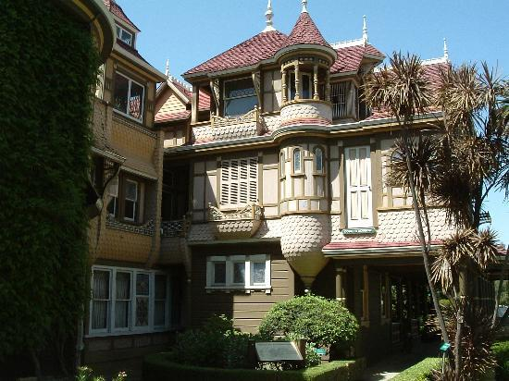

Imagine you are on holiday. Write a postcard to your best friend at home. Tell him/ her where you are and what it is like. Where did you go and what did you see? Say hello and goodbye.

